Contents

Modules 1

Module ‘Assembly’ and ‘Operator’ 1

Module ‘Slot Data’ 2

Module ‘Order planning’ 3

Tab ‘Order’ 3

Tab ‘Product details’ 4

Tab ‘Operations’ 5

Tab ‘Mfg Tetst’ 6

Tab ‘Work o.BOM’ 7

Tab ‘Operation BOM’ 8

Tab ‘Slot requirement’ & ‘Report setup’ 9

Module ‘Ware House’ 10

Module ‘QC/Admin’ 11

Module ‘Report a Bug’ 13

# Modules

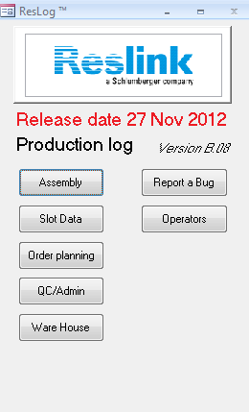

* On front page there should be seven modules:
* Assembly- for operators to use when production
* Slot data- import ResGauge slot control file to ResLog
* Order planning- for administrator to setup work order package
* QC/Admin- for quality to document IFR’s/hold joints
* Ware House- to issue parts to WO and document traceability to activate BOM drop down list at assembly module
* Report a Bug- report software bugs/submit tickets
* Operators- users authority control

Detailed function requirement

# Module ‘Assembly’ and ‘Operator’

The new Reslog terminal for users should be programmed in a way which is possible to run from similar hardware such as ipads. The operators should therefore have a more flexible way to enter the real time data from the workshop. We should **seriously** consider these portable terminals solution together with bar code WO/components scanner when implementing the project.

Basically these two modules could meet customer requirement per current function.

# Module ‘Slot Data’

**Current**

At current ResLog version B, it provides slot data import to the ResLog per module ‘Slot Data’ tab ‘Slot Import’.

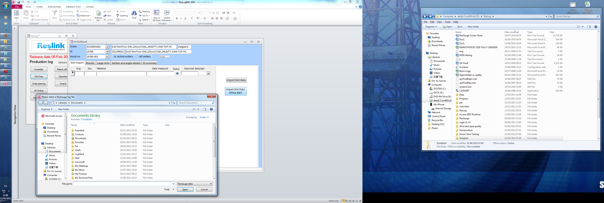

The import process is manually as the follows:

Operator runs camera🡪Save the slot data file (A notepad file) generated to P: naming if as ‘WO ID-joint serial no.’🡪Open ResLog module ‘slot control’ 🡪 Go to tab ‘slot import’ 🡪 click ‘import slot data office 2007’ 🡪 Choose the data file he saved from P:

**Expectation**

The basic idea is the automation of the above process. When ResGauge is running, the in-time slot data documented is saved at P: with the correct file name. Choosing WO ID and serial no. from the drop down list, and clicking import slot data button, system auto-search the corresponding data file per the name. A pop-out window could be displayed for the operator to choose which file he would like to import. We could automate the slot data saving and file choose process first at the point.

Multiple slot data import is needed when repairing/cutting the jacket. All previous import should be saved in system with time but not over-written when import again to keep trace on the wrapping.

# Module ‘Order planning’

User guide for current version refers to 101245223

## Tab ‘Order’

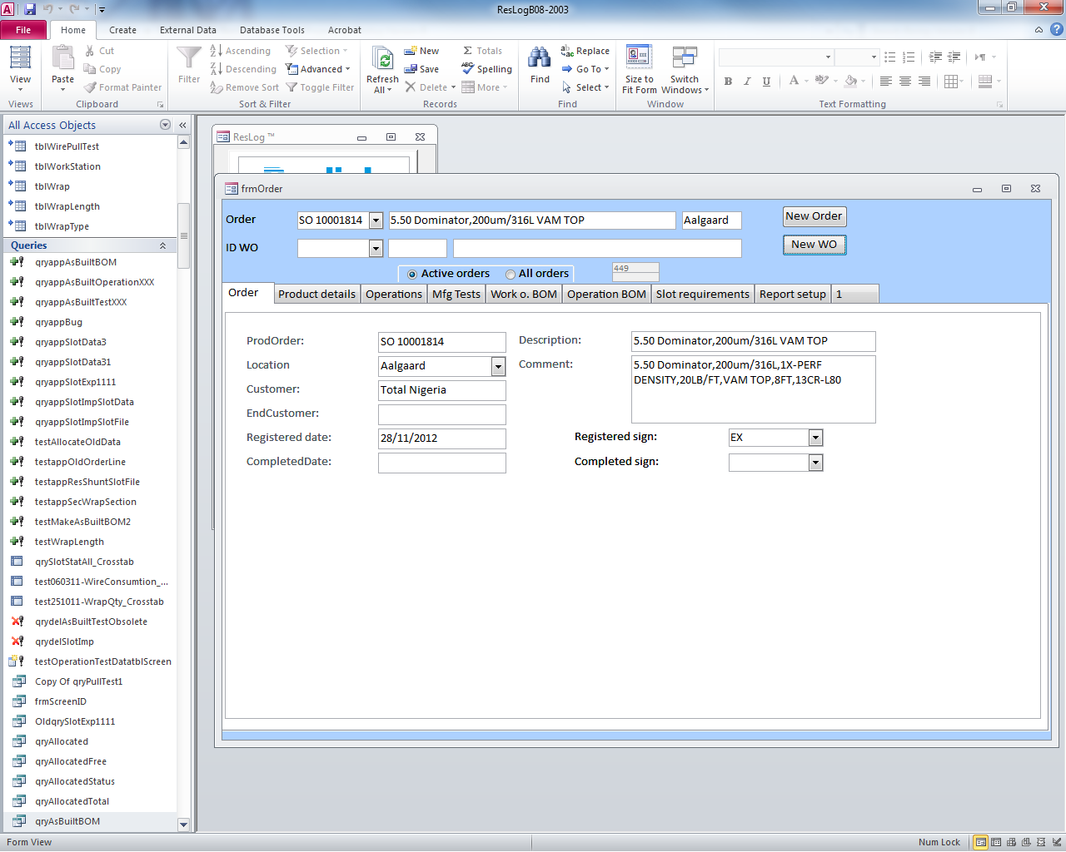

**Current**:

ProdOrder- input SO number manually; inputs will be displayed at ‘Order’ drop down list

Location- drop down list to choose Reslink locations

Customer- input customer manually

Description- input description manually

Comments input main product information manually

**Expectation**:

At the drop down list, SO drop down list is auto synchronized from mfg/pro after site selection

Description is auto synchronized from mfg/pro

Customer is auto synchronized from mfg/pro

## Tab ‘Product details’

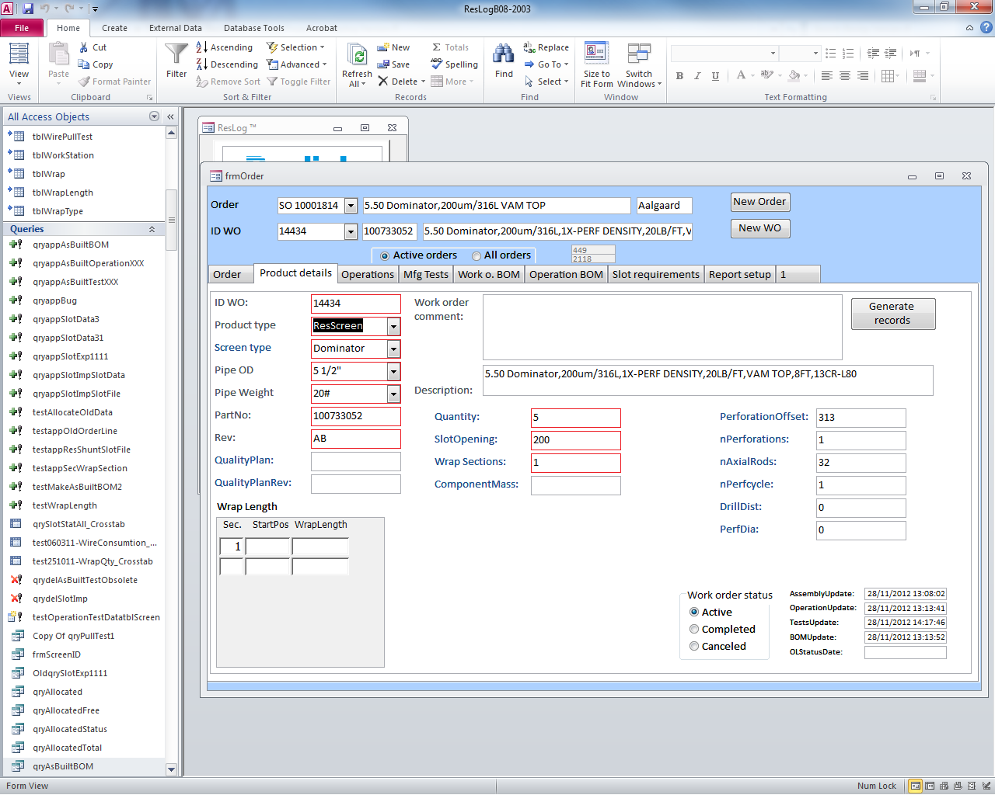

**Current**

ID WO-input manually and the result is displayed at ID WO drop down list

Product type-Drop down list to choose the standard product families

Screen type-Drop down list to choose wrapping types

Pipe OD-Drop down list to choose tubing sizes

Pipe weight-Drop down list to choose tubing weight

PartNo-Product part number; manually input

All other columns you could see are all manually input

**Expectation**

ID WO automatic from mfg/pro after chosen SO numbers

PartNo automatic from mfg/pro after chosen WO

Quantity automatic from mfg/pro after chosen WO

## Tab ‘Operations’

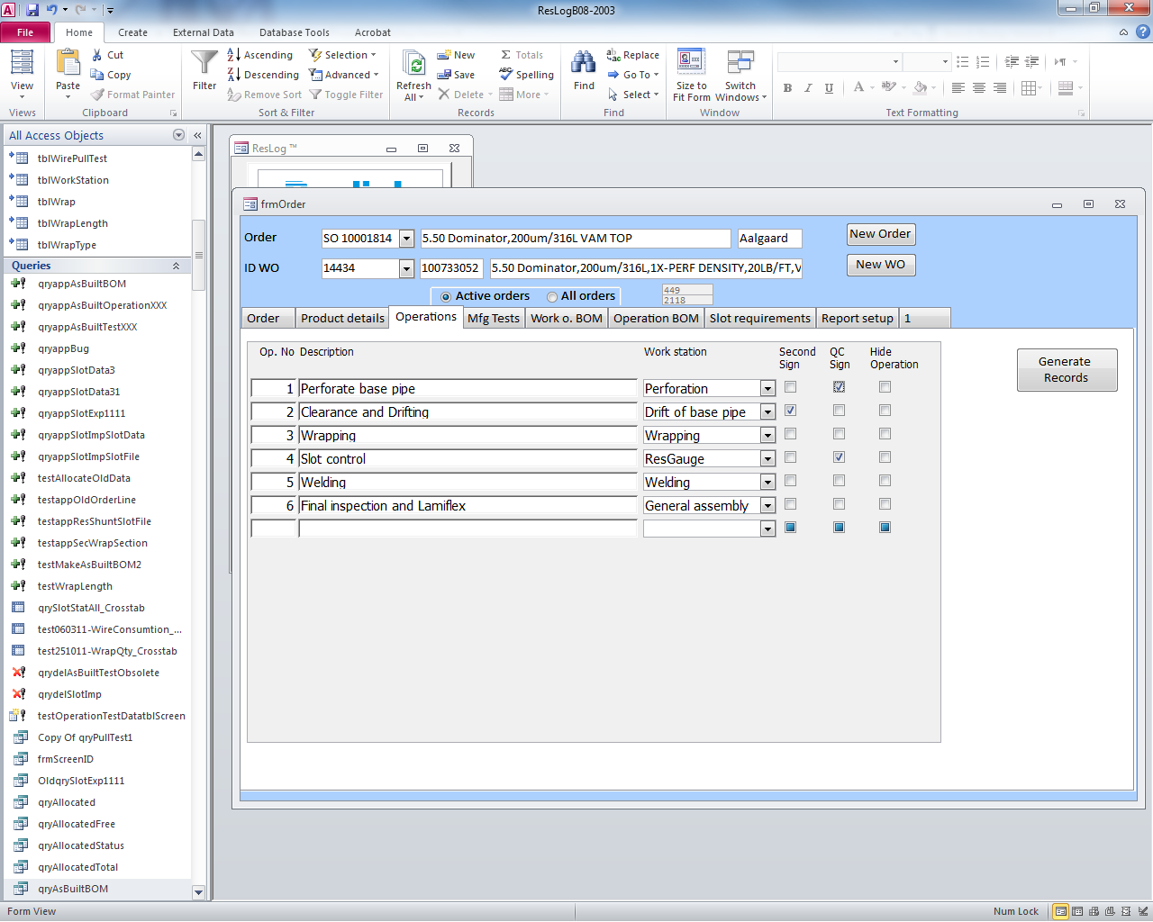

**Current**

Manually input operations as router

Drop down list to choose work center/station

Check box if second sign/QC control required

Hide Operation functions as delete lines

**Expectation**

Have a function to preset **router templates** for different products and has a router templates import function at this tab. All operations are auto import after chosen router templates and delete function to delete the operations not need. Router templates could be either preset in ResLog or in mfg/pro(then should be auto imported per routing codes in mfg/pro).

For either way, a router templates edit function needs to be in ResLog to identify for each function, what are the mfg tests which need so that could automate tab ‘Mfg Tests’ (Details see next paragraph)

## Tab ‘Mfg Tetst’

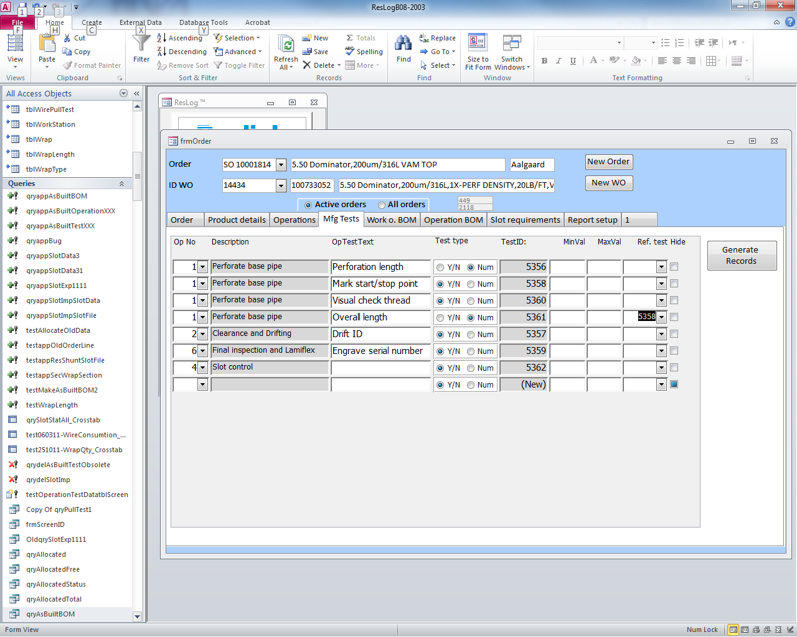

**Current**

Drop down list to choose operation number then manually input OpTestText; choose Test type and input minval, maxval; Ref.test is to link tests

Hide functions as delete

**Expectation**

With the router templates edit function, standard mfg tests could be preset to different operation numbers. Router templates imported at ‘Operations’, all the tests from the existing operations should be automatically imported here. Test type should be a check box to choose when setting routing templates and auto downloaded here(but editable at this page)

Maxval; minval and ref.tests could use the current ways

Delete function and manually adding new tests need to be here.

## Tab ‘Work o.BOM’

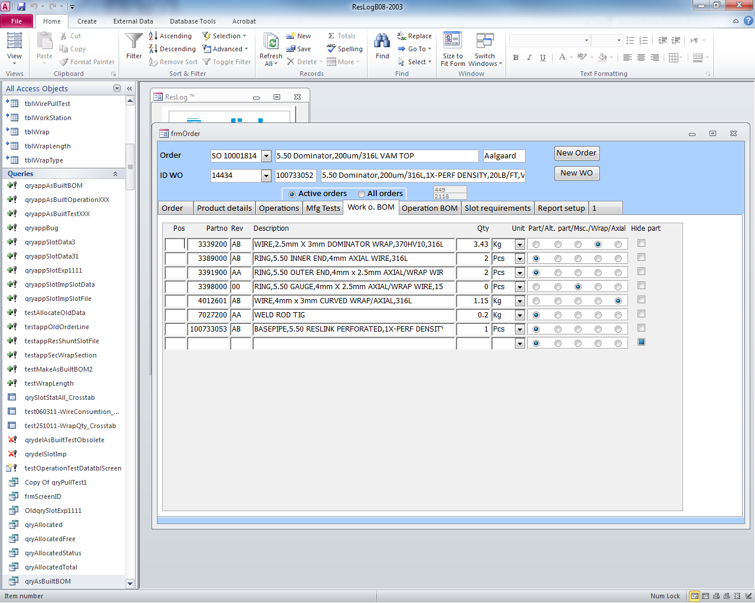

**Current**

Manually input the BOM from GeMs

**Expectation**

After part.no chosen, BOM should be automatically imported from mfg/pro BOM structure

Qty/Unit should be auto imported but manually editable here

Different BOM type should be auto imported but manually editable here.

Delete function and manually adding new tests need to be here.

## Tab ‘Operation BOM’

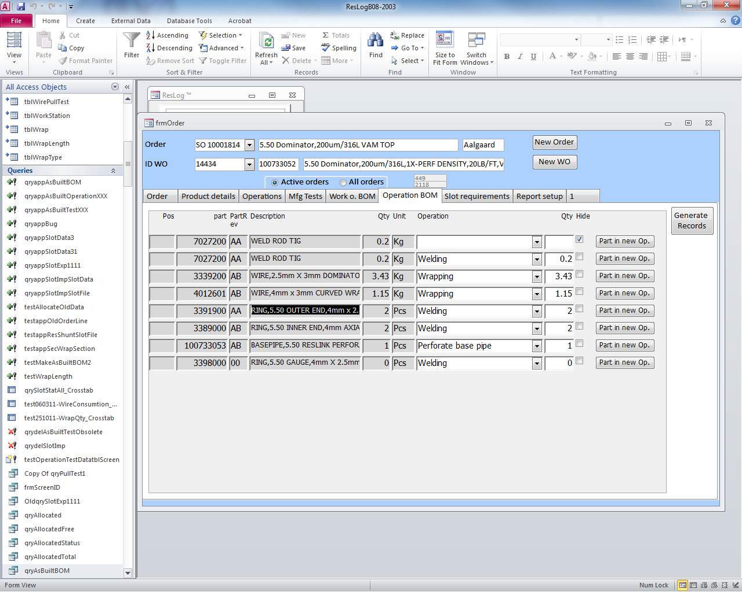

**Current**

Link BOM from previous tab to router operations

**Expectation**

This tab could be still manually linked by the administrators and with a delete function

## Tab ‘Slot requirement’ & ‘Report setup’

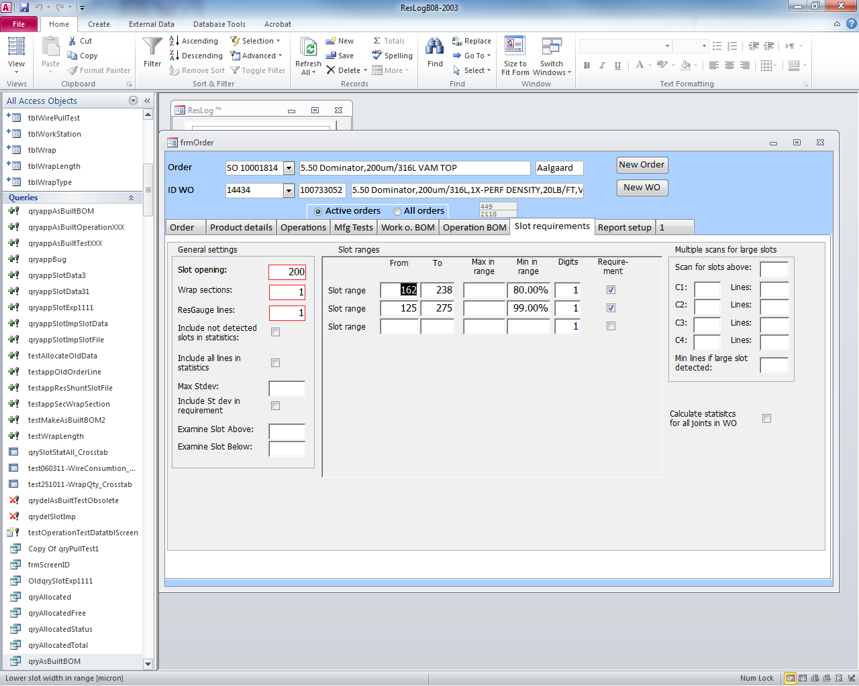

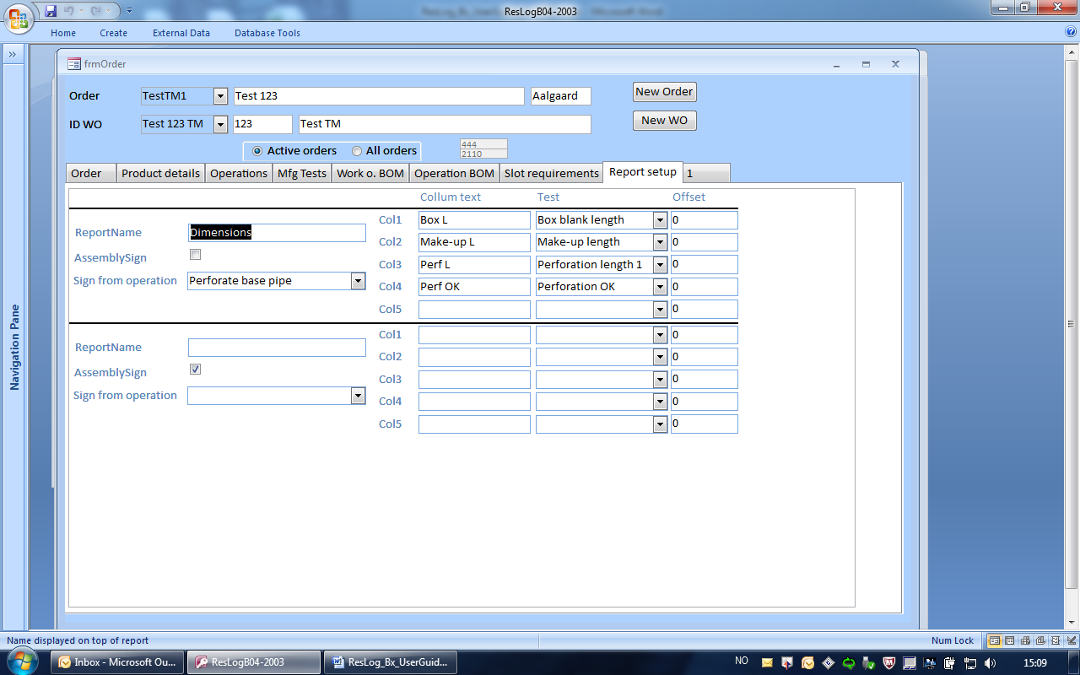

These two tabs do not have extra requirements.

# Module ‘Ware House’

A form is generated for the administrator to allocate the components with traceability. The BOM is displayed on top as a list box when Work o. BOM is setup at ‘Order planning’ module. No changes need to be made to the BOM down load way.

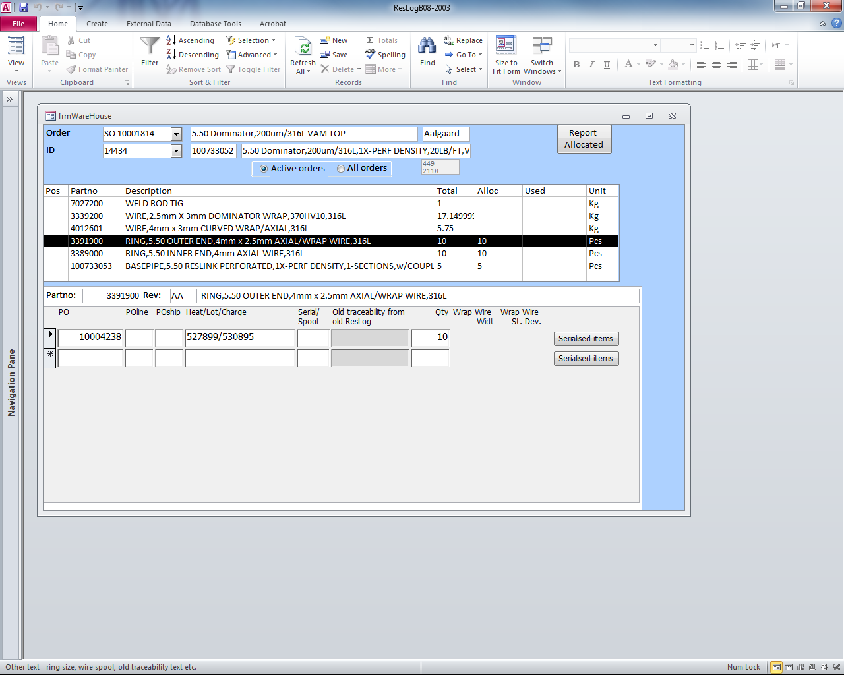

**Current**

All input is done manually now. The administrator find the issue-to-WO information from mfg/pro and input the traceability and quantity manually.

**Expectation**

After components issued to WO in mfg/pro, by choosing the WO ID, the PO/Lot information is auto imported to the list with quantity. Manual edit on traceability and lines delete function needs to be there. Manual adding lines is also needed. The administrator should confirm the traceability information at this module before they are displayed at ‘assembly’ module.

Serialization function is still required. For RSLN this function may need at wires; RSLU may need for ResShunt production.

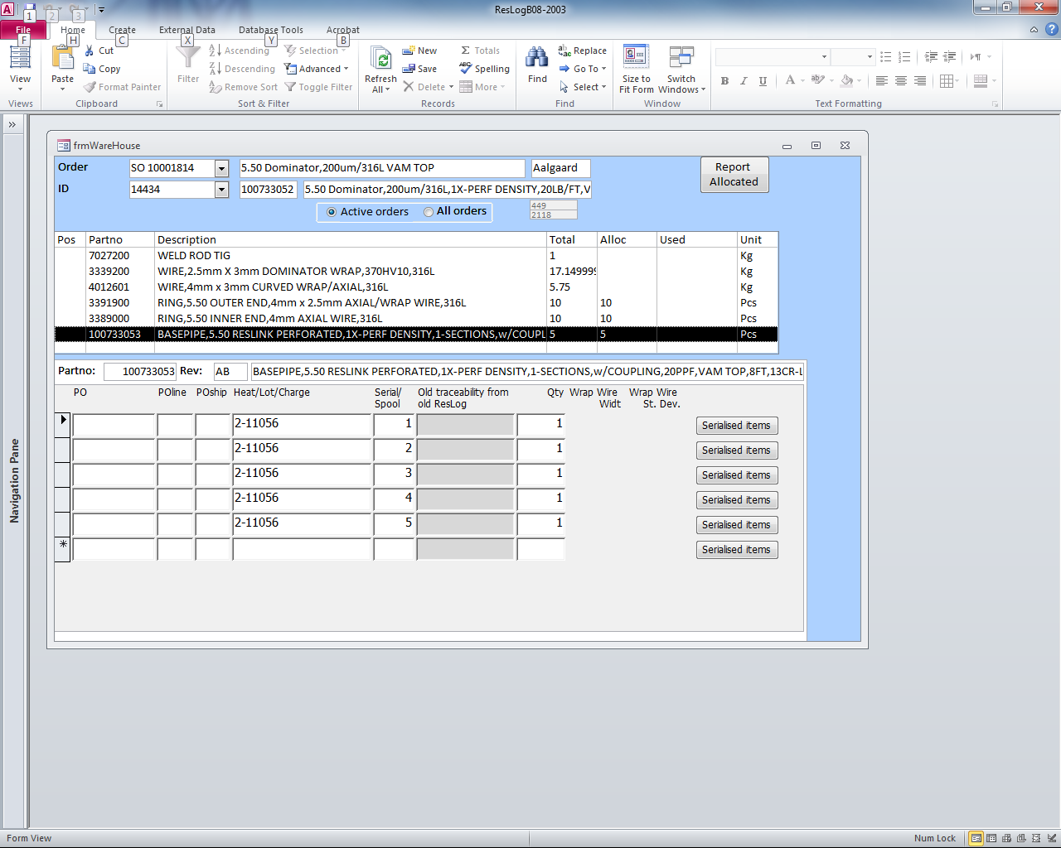

# Module ‘QC/Admin’

**Current**

We have the following tabs now

* ID status- a status summary for joints serial no, NC status, progress, hide (function as delete), assy date and sign
* Status-Manual input NC text with lock function
* Pull off-Pull off test status for wrapping sections
* Hardness-Hardness test record
* Reports-QC report summary status
* Slot summary-Slot control report after ResGauge imported
* Ship-joints shipment report
* Parts allocated-Traceability report from warehouse module

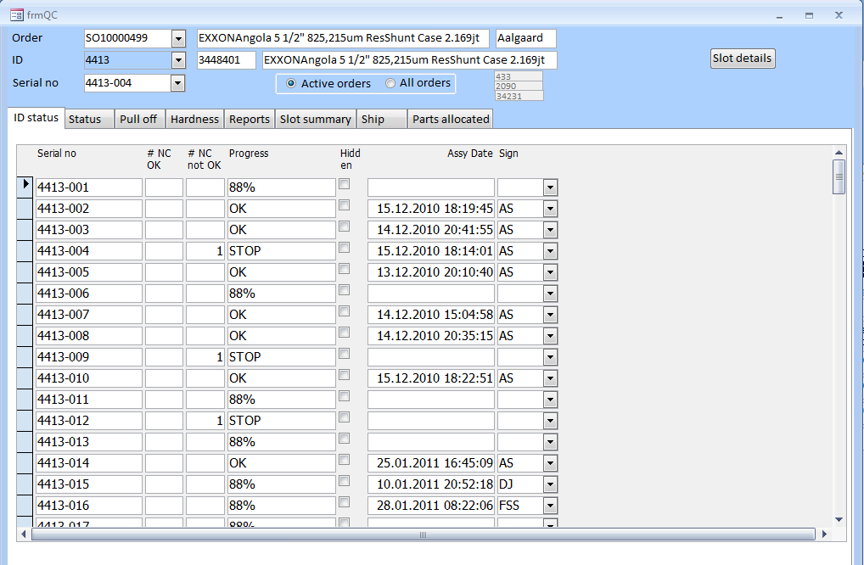

**Expectation**

All the QC terminology definition should be streamlined with eQuality- NC🡪IFR for example.

At tab ‘status’, chosen joint serial number, the IFR status should be auto imported from eQuality, with a manual edit function at ResLog.

The main improve at this module is to improve the integration with eQuality data as much as possible.

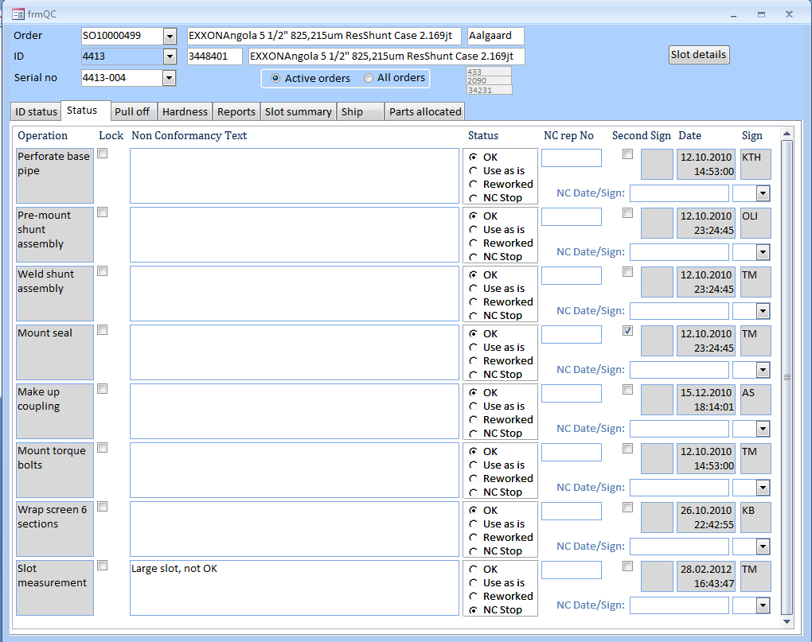

# Module ‘Report a Bug’

**Current**

This module is used to report a bug now and it is only documented in ResLog.

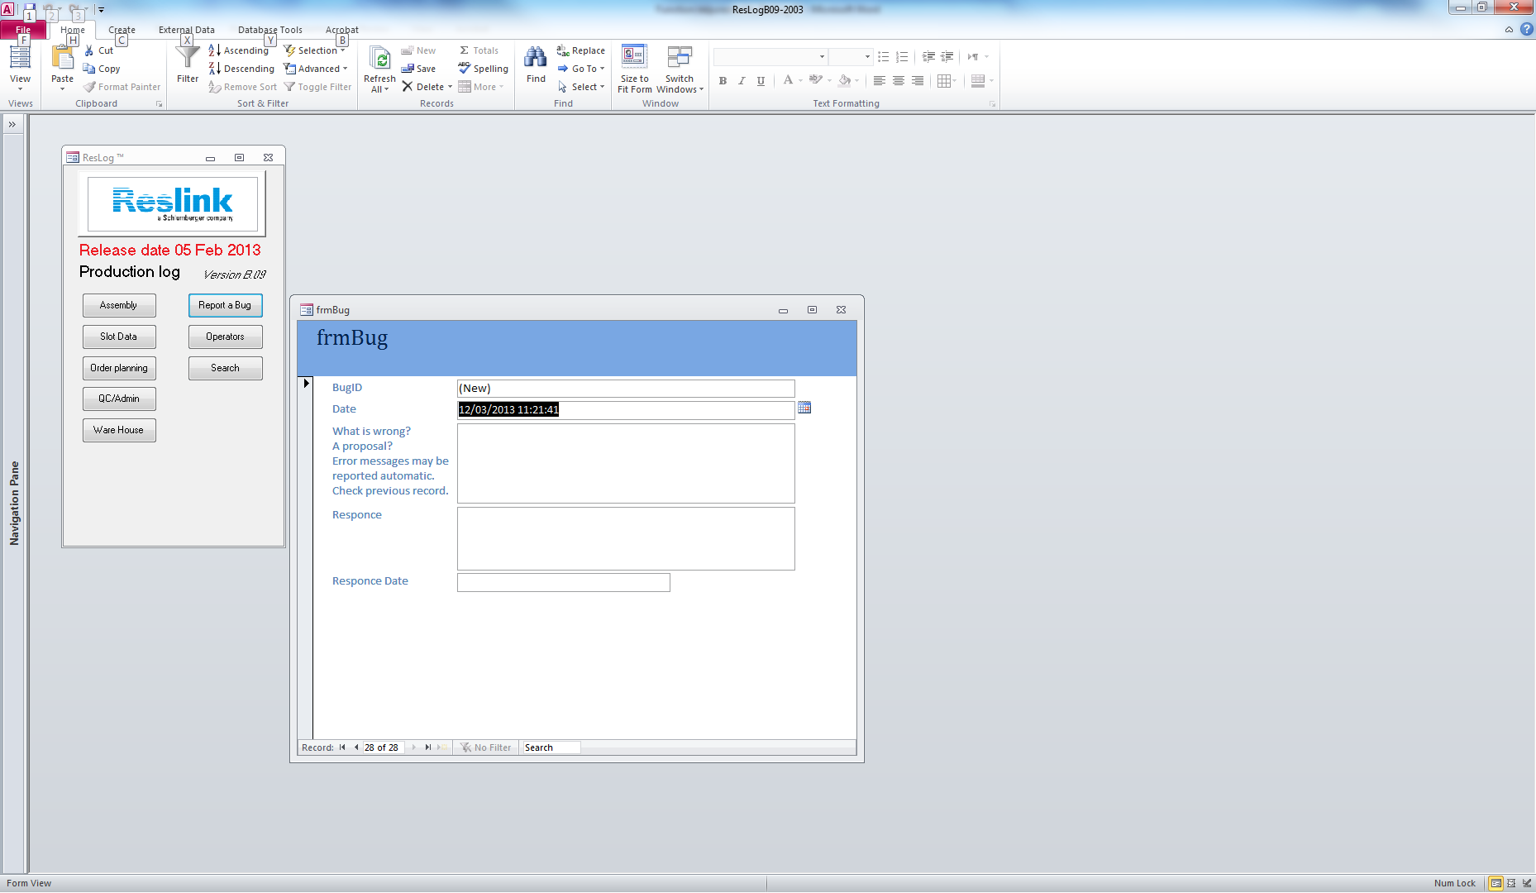

**Expectation**

Change to a module such as submitting a ticket. After input by the users, a ticket email will be sent to the software supporting team, with ticket ID traceability function.